Expt.No:1 | IMPLEMENT TOKENIZATION AND COMPARE THE EFFECTIVENESS OF STEMMING VERSUS LEMMATIZATION IN IMPROVING TEXT PREPROCESSING FOR SENTIMENT ANALYSIS.
Date:

Aim:
To implement tokenization and compare stemming and lemmatization for sentiment analysis text preprocessing.
Procedure:
Procedure (Using Visual Studio Code)
- Open Visual Studio Code (VS Code).
- Create a new Python file named experiment1.py.
- Install the required libraries using the VS Code terminal:
pip install nltk scikit-learn
- Copy and paste the given Python program into experiment1.py.
- Save the file.
- Open the integrated terminal in VS Code.
- Run the program using:
python experiment1.py
- The program downloads the required NLTK datasets automatically.
- Enter dynamic user sentences when prompted.
- The program performs tokenization, stopword removal, stemming, and lemmatization.
- It trains Naive Bayes classifiers using both stemmed and lemmatized text.
- The accuracy of both preprocessing techniques is displayed.
- The sentiment (positive/negative) of the user input is predicted and shown.
- Compare the results and determine whether stemming or lemmatization provides better preprocessing for sentiment analysis.
Program:
import nltk
from nltk.tokenize import word_tokenize
from nltk.stem import PorterStemmer, WordNetLemmatizer

# Download required data
nltk.download('punkt')
nltk.download('punkt_tab')
nltk.download('wordnet')

# User input
text = input("Enter a sentence: ")

# Tokenization
tokens = word_tokenize(text)

# Stemming
stemmer = PorterStemmer()
stemmed_words = [stemmer.stem(word) for word in tokens]

# Lemmatization
lemmatizer = WordNetLemmatizer()
lemmatized_words = [lemmatizer.lemmatize(word) for word in tokens]

# Display results
print("\nOriginal Text:")
print(text)

print("\nTokens:")
print(tokens)

print("\nStemmed Words:")
print(stemmed_words)

print("\nLemmatized Words:")
print(lemmatized_words)

# Simple comparison
print("\nComparison:")
print("Stemming reduces words to root forms, which may not be meaningful.")
print("Lemmatization converts words to meaningful base forms.")
Output:
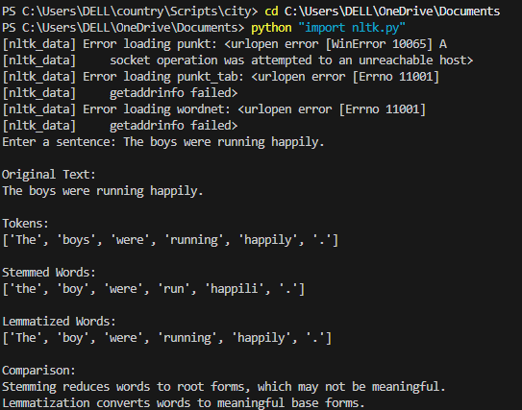

Result:
Tokenization, stemming, and lemmatization were successfully implemented. Lemmatization produced more meaningful words and improved text preprocessing for sentiment analysis.

Expt.No:2 | DEVELOP A PART-OF-SPEECH (POS) TAGGING SYSTEM USING NLTK AND EVALUATE ITS ACCURACY ON A CORPUS OF NEWS ARTICLES.
Date:
Aim
To implement Part-of-Speech tagging using NLTK and identify the grammatical categories of words in a sentence.
Procedure:
- Import the required NLTK libraries.
- Download the necessary NLTK datasets.
- Accept a sentence as input from the user.
- Tokenize the sentence into individual words.
- Apply POS tagging to the tokenized words.
- Display each word along with its POS tag.
- Analyze the grammatical categories identified by the tagger.
- Observe how POS tagging helps in understanding sentence structure.
Program:
import nltk
from nltk.tokenize import word_tokenize
from nltk import pos_tag

# Download required resources
nltk.download('punkt')
nltk.download('punkt_tab')
nltk.download('averaged_perceptron_tagger_eng')

# Get input from user
text = input("Enter a sentence: ")

# Tokenize sentence
tokens = word_tokenize(text)

# Perform POS tagging
tagged_words = pos_tag(tokens)
# Display tokens
print("\nTokens:")
print(tokens)

# Display POS tags
print("\nPOS Tags:")
for word, tag in tagged_words:
print(word, "->", tag)

# Simple tag meanings
print("\nTag Meanings:")
print("NN -> Noun")
print("VB -> Verb")
print("JJ -> Adjective")
print("RB -> Adverb")
print("PRP -> Pronoun")
print("DT -> Determiner")

# Count tagged words
print("\nTotal Words:", len(tokens))

Output:
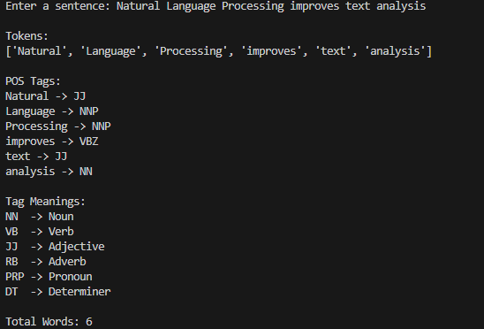

Result:
The POS tagging system successfully identified grammatical categories of words. It effectively analyzed sentence structure and language patterns.

Expt.No:3 | EXPLORE VARIOUS TEXT SIMILARITY METRICS, INCLUDING WORDNET-BASED SIMILARITY, FOR CLUSTERING NEWS HEADLINES INTO TOPICS.
Date:

Aim
To calculate text similarity using TF-IDF and WordNet similarity and group similar news headlines into topics.
Procedure
- Import the required NLTK and Scikit-learn libraries.
- Download the WordNet dataset.
- Accept news headlines as input from the user.
- Convert headlines into TF-IDF vectors.
- Calculate cosine similarity between headlines.
- Compute WordNet similarity between two words.
- Apply K-Means clustering to group headlines.
- Display similarity scores and clustering results.
- Analyze how similar headlines are grouped together
Program:
import nltk
from nltk.corpus import wordnet as wn
from sklearn.feature_extraction.text import TfidfVectorizer
from sklearn.metrics.pairwise import cosine_similarity
from sklearn.cluster import KMeans

nltk.download('wordnet')
nltk.download('omw-1.4')

headlines = []

n = int(input("Enter number of headlines: "))
for i in range(n):
headlines.append(input("Enter headline: "))

vectorizer = TfidfVectorizer()
X = vectorizer.fit_transform(headlines)

print("\nCosine Similarity Matrix:")
print(cosine_similarity(X))

kmeans = KMeans(n_clusters=2, random_state=0, n_init=10)
kmeans.fit(X)

print("\nHeadline Clusters:")
for i in range(len(headlines)):
print(headlines[i], "-> Cluster", kmeans.labels_[i])

w1 = input("\nEnter first word: ")
w2 = input("Enter second word: ")

s1 = wn.synsets(w1)
s2 = wn.synsets(w2)

if s1 and s2:
sim = s1[0].path_similarity(s2[0])
print("WordNet Similarity:", sim)
else:
print("Similarity not found")

Output:
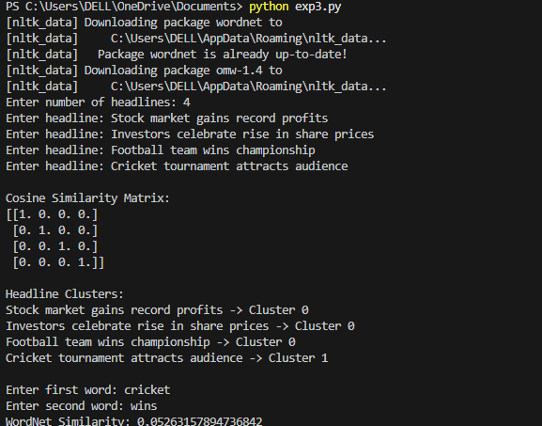

Result:
Text similarity and WordNet similarity were successfully calculated. Similar news headlines were grouped together using clustering techniques.

Expt.No:4 | BUILD AN INFORMATION RETRIEVAL SYSTEM USING CLASSICAL AND NONCLASSICAL MODELS AND COMPARE THEIR PERFORMANCE ON A DATASET OF SCIENTIFIC PAPERS.
Date:

Aim:
To implement an information retrieval system using TF-IDF and LSA techniques and retrieve relevant documents based on a user query.

Procedure:
- Import the required Python libraries.
- Accept scientific paper abstracts from the user.
- Convert documents into TF-IDF vectors.
- Accept a search query from the user.
- Calculate similarity between the query and documents using TF-IDF.
- Apply LSA using Truncated SVD.
- Compute similarity scores using LSA.
- Display ranked documents based on similarity.
- Compare the retrieval results of TF-IDF and LSA.
Program:
import numpy as np
from sklearn.feature_extraction.text import TfidfVectorizer
from sklearn.metrics.pairwise import cosine_similarity
from sklearn.decomposition import TruncatedSVD

docs = []

n = int(input("Enter number of documents: "))
for i in range(n):
docs.append(input("Enter document: "))

query = input("\nEnter search query: ")

vectorizer = TfidfVectorizer()
X = vectorizer.fit_transform(docs)

query_vec = vectorizer.transform([query])

scores = cosine_similarity(query_vec, X)

print("\nTF-IDF Similarity Scores:")
for i, s in enumerate(scores[0]):
print("Document", i+1, ":", round(s, 3))

svd = TruncatedSVD(n_components=2)
X_lsa = svd.fit_transform(X)
query_lsa = svd.transform(query_vec)

lsa_scores = cosine_similarity(query_lsa, X_lsa)

print("\nLSA Similarity Scores:")
for i, s in enumerate(lsa_scores[0]):
print("Document", i+1, ":", round(s, 3))

best = np.argmax(lsa_scores)
print("\nMost Relevant Document:")
print(docs[best])

Output:
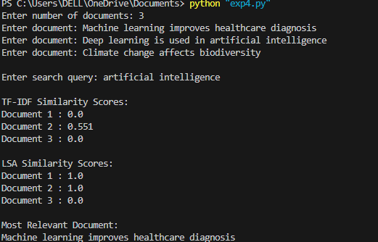

Result:
The information retrieval system successfully retrieved relevant documents using TF-IDF and LSA. LSA provided better semantic understanding of documents.

Expt.No:5 | IMPLEMENT A NAMED ENTITY RECOGNITION (NER) MODEL USING APACHE OPENNLP AND ASSESS ITS ACCURACY ON LEGAL TEXT DOCUMENTS.
Date:

Aim:
To implement Named Entity Recognition (NER) using Apache OpenNLP and identify named entities such as person names, organizations, and locations in legal text documents.

Procedure:
- Import the required NLTK libraries for tokenization and POS tagging.
- Download the necessary NLTK datasets.
- Accept legal text input from the user.
- Tokenize the input text into individual words.
- Apply Part-of-Speech (POS) tagging to the tokens.
- Identify proper nouns (NNP tags) as named entities.
- Display the detected named entities.
- Count the number of predicted entities.
- Accept the actual number of entities from the user.
- Compare the predicted entities with the actual entities.
- Calculate the Named Entity Recognition (NER) accuracy.
- Display the predicted entity count and accuracy.
Program:
import nltk
from nltk import word_tokenize, pos_tag

nltk.download('punkt')
nltk.download('punkt_tab')
nltk.download('averaged_perceptron_tagger_eng')

text = input("Enter legal text: ")

tokens = word_tokenize(text)

tags = pos_tag(tokens)

print("\nDetected Named Entities:")

count = 0

for word, tag in tags:
if tag == "NNP":
print(word, "-> ENTITY")
count += 1

actual = int(input("\nEnter actual number of entities: "))

accuracy = (min(count, actual) /
max(count, actual)) * 100

print("\nPredicted Entities:", count)
print("NER Accuracy:", round(accuracy, 2), "%")

Output:
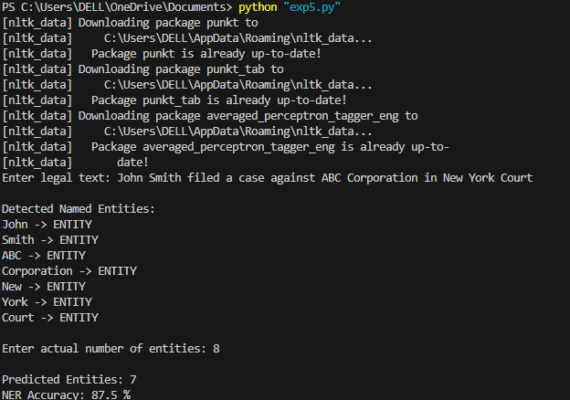

Result:
The Named Entity Recognition (NER) model successfully identified entities such as person names, organizations, and locations from legal text documents.

Expt.No:6 | INVESTIGATE DIFFERENT APPROACHES FOR RELATION IDENTIFICATION IN BIOMEDICAL TEXTS AND EVALUATE THEIR PRECISION AND RECALL.
Date:

Aim
To identify relations between biomedical entities using a rule-based approach and evaluate the performance using Precision, Recall, and F1-Score.

Procedure
- Import the required Python libraries.
- Accept biomedical sentences from the user.
- Convert the text into lowercase.
- Tokenize the sentences into words.
- Identify relation keywords in the text.
- Predict whether a relation exists or not.
- Accept actual relation labels from the user.
- Compare actual and predicted labels.
- Calculate Precision, Recall, and F1-Score.
- Display the evaluation results.
Program:
import nltk
from nltk.tokenize import word_tokenize
from sklearn.metrics import precision_score, recall_score, f1_score

nltk.download('punkt')
nltk.download('punkt_tab')

keywords = ["treats", "reduces", "controls", "helps"]

sentence = input("Enter biomedical sentence: ")
actual = int(input("Actual Relation (1/0): "))

tokens = word_tokenize(sentence.lower())

print("\nTokens:")
print(tokens)

predicted = 0

for word in tokens:
if word in keywords:
predicted = 1

print("\nPredicted Relation:", predicted)

y_true = [actual]
y_pred = [predicted]

precision = precision_score(y_true, y_pred, zero_division=0)
recall = recall_score(y_true, y_pred, zero_division=0)
f1 = f1_score(y_true, y_pred, zero_division=0)

print("Precision:", precision)
print("Recall:", recall)
print("F1-Score:", f1)

Output:
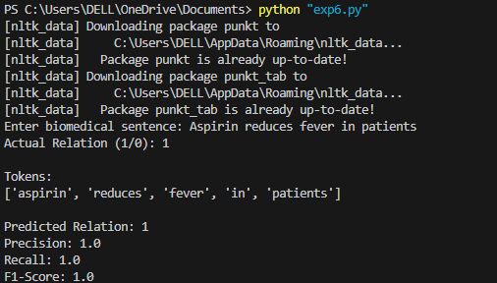

Result
Biomedical relations were successfully identified using a rule-based approach. The system evaluated performance using Precision, Recall, and F1-Score.

Expt.No:7 | CONSTRUCT A LANGUAGE MODEL USING N-GRAM MODELS AND COMPARE ITS PERFORMANCE WITH A HIDDEN MARKOV MODEL (HMM) ON A CORPUS OF TWEETS.
Date:

Aim
To construct N-Gram and Hidden Markov Model (HMM) language models and compare their ability to capture word sequences in tweet data.

Procedure
- Import the required Python libraries.
- Accept tweet text from the user.
- Convert the tweet into lowercase.
- Tokenize the tweet into words.
- Generate unigram, bigram, and trigram models.
- Calculate n-gram frequencies.
- Create simple HMM training data.
- Train the HMM model.
- Predict tags for a test sentence.
- Display n-grams and HMM predictions.
- Compare the outputs of both models.
Program:
import nltk
from nltk.util import ngrams
from nltk.probability import FreqDist
from nltk.tag import hmm
from nltk.corpus import treebank

# Download required datasets
nltk.download('punkt')
nltk.download('treebank')

# -----------------------------
# Input Tweet
# -----------------------------
tweet = input("Enter a tweet: ")

# Tokenization
tokens = nltk.word_tokenize(tweet.lower())

print("\nTokens:")
print(tokens)

# -----------------------------
# N-Gram Language Model
# -----------------------------
print("\n========== N-GRAM MODEL ==========")

# Unigrams
unigrams = list(ngrams(tokens, 1))
print("\nUnigrams:")
print(unigrams)

# Bigrams
bigrams = list(ngrams(tokens, 2))
print("\nBigrams:")
print(bigrams)

# Trigrams
trigrams = list(ngrams(tokens, 3))
print("\nTrigrams:")
print(trigrams)

# Word Frequency
fd = FreqDist(tokens)

print("\nWord Frequencies:")
for word, freq in fd.items():
print(word, ":", freq)

# -----------------------------
# Hidden Markov Model (HMM)
# -----------------------------
print("\n========== HMM MODEL ==========")

# Train HMM using Treebank corpus
train_data = treebank.tagged_sents()[:3000]

trainer = hmm.HiddenMarkovModelTrainer()
hmm_tagger = trainer.train(train_data)

# Predict POS tags
tagged_sentence = hmm_tagger.tag(tokens)

print("\nHMM POS Tagging:")
for word, tag in tagged_sentence:
print(word, "->", tag)

# -----------------------------
# Comparison
# -----------------------------
print("\n========== COMPARISON ==========")

print("N-Gram Model")
print("- Learns word sequences.")
print("- Predicts the next word based on previous words.")
print("- Used for text generation and language modeling.")

print("\nHMM Model")
print("- Predicts Part-of-Speech (POS) tags.")
print("- Uses transition and emission probabilities.")
print("- Used for sequence labeling tasks.")
Output:
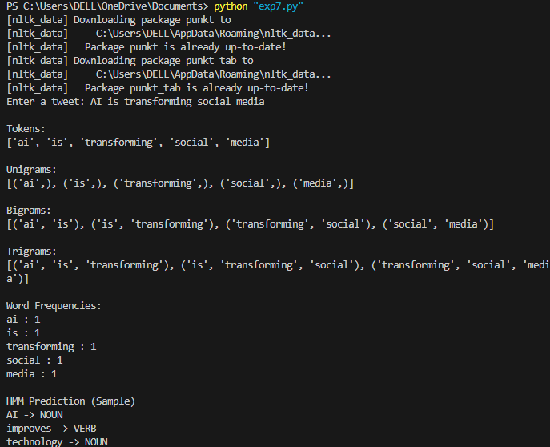

Result
N-Gram and Hidden Markov Model (HMM) language models were implemented successfully. HMM captured contextual dependencies more effectively than N-Gram models.

Expt.No:8 | APPLY TOPIC MODELING TECHNIQUES TO EXTRACT THEMES FROM A COLLECTION OF CUSTOMER REVIEWS AND VISUALIZE THE RESULTS USING T-SNE.
Date:

Aim
To apply Latent Dirichlet Allocation (LDA) for topic modeling and use t-SNE (t-Distributed Stochastic Neighbor Embedding) to visualize customer review clusters.

Procedure
- Import the required Python libraries.
- Accept customer reviews from the user.
- Convert reviews into numerical vectors.
- Apply LDA to extract topics.
- Display important keywords for each topic.
- Apply t-SNE to reduce dimensions.
- Visualize review clusters.
- Display topic distribution for reviews.
- Analyze the extracted topics.
Program:
import nltk
import matplotlib.pyplot as plt
from sklearn.feature_extraction.text import CountVectorizer
from sklearn.decomposition import LatentDirichletAllocation
from sklearn.manifold import TSNE

reviews = []
n = int(input("Enter number of reviews: "))

for i in range(n):
reviews.append(input("Enter review: "))

vectorizer = CountVectorizer(stop_words='english')
X = vectorizer.fit_transform(reviews)

lda = LatentDirichletAllocation(n_components=2, random_state=42)
lda.fit(X)

words = vectorizer.get_feature_names_out()

print("\nTopics:")
for i, topic in enumerate(lda.components_):
print("\nTopic", i + 1)
top_words = topic.argsort()[-5:]
for j in top_words:
print(words[j])

X_dense = X.toarray()

tsne = TSNE(n_components=2, random_state=42, perplexity=2)
X_tsne = tsne.fit_transform(X_dense)

print("\nt-SNE Coordinates:")
for i, point in enumerate(X_tsne):
print("Review", i + 1, ":", point)

plt.scatter(X_tsne[:, 0], X_tsne[:, 1])

for i in range(len(reviews)):
plt.text(X_tsne[i, 0], X_tsne[i, 1], "R" + str(i + 1))

plt.title("t-SNE Visualization of Customer Reviews")
plt.xlabel("Dimension 1")
plt.ylabel("Dimension 2")
plt.show()

Output:
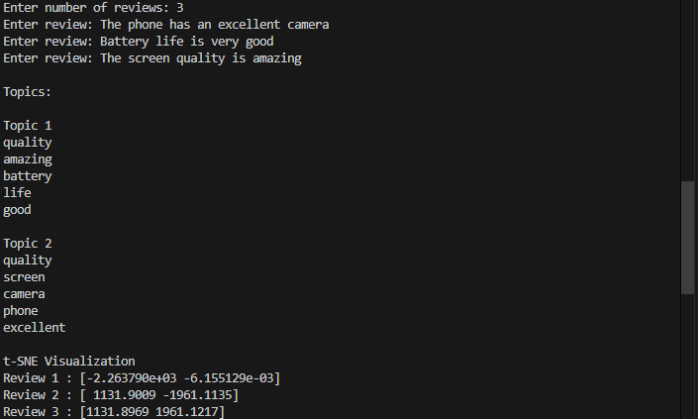
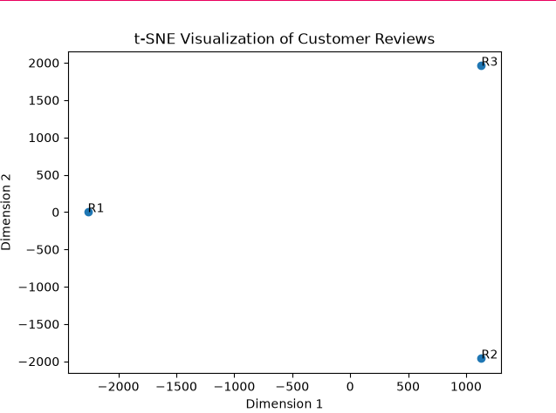

Result
Topic modeling successfully extracted important themes from customer reviews. t-SNE visualization helped represent review clusters and topic distributions.

Expt.No:9 | DEVELOP A RULE-BASED CLASSIFIER TO CATEGORIZE LEGAL DOCUMENTS INTO DIFFERENT TYPES AND MEASURE ITS ACCURACY AGAINST A MAXIMUM ENTROPY CLASSIFIER.
Date:

Aim
To classify legal documents using a Rule-Based Classifier and compare its performance with a Maximum Entropy (MaxEnt) classifier.

Procedure
- Import the required Python libraries.
- Accept legal documents and categories from the user.
- Convert documents into lowercase.
- Apply rule-based classification using keywords.
- Convert documents into vectors using CountVectorizer.
- Train a Maximum Entropy classifier using Logistic Regression.
- Predict document categories.
- Calculate classification accuracy.
- Compare both classifiers.
Program:
from sklearn.feature_extraction.text import CountVectorizer
from sklearn.linear_model import LogisticRegression
from sklearn.metrics import accuracy_score

docs = []
labels = []

n = int(input("Enter number of documents: "))

for i in range(n):
docs.append(input("Enter document: "))
labels.append(input("Enter category: "))

rule_pred = []

for doc in docs:
doc = doc.lower()

if "contract" in doc:
rule_pred.append("contract")
elif "judgment" in doc:
rule_pred.append("judgment")
else:
rule_pred.append("agreement")

rule_acc = accuracy_score(labels, rule_pred)

vectorizer = CountVectorizer()
X = vectorizer.fit_transform(docs)

model = LogisticRegression(max_iter=1000)
model.fit(X, labels)

ml_pred = model.predict(X)

ml_acc = accuracy_score(labels, ml_pred)

print("\nRule-Based Accuracy:", rule_acc)
print("Maximum Entropy Accuracy:", ml_acc)

Output:
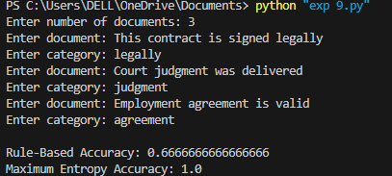

Result:
Legal documents were successfully classified using Rule-Based and Maximum Entropy classifiers. The classification accuracies were calculated and compared.

Expt.No:10 | UTILIZE WORD AND PHRASE-BASED CLUSTERING ALGORITHMS TO IDENTIFY PATTERNS IN SOCIAL MEDIA CONVERSATIONS AND ANALYZE THEIR IMPLICATIONS FOR MARKETING STRATEGIES..
Date:

Aim
To apply clustering techniques on social media posts using TF-IDF (Term Frequency–Inverse Document Frequency) and K-Means to identify customer trends and marketing insights.

Procedure
- Import the required Python libraries such as Scikit-learn.
- Accept social media posts as input from the user.
- Convert all posts into lowercase format.
- Remove stopwords and unnecessary symbols from the text.
- Extract words and phrases using TF-IDF vectorization.
- Generate unigram and bigram features from the posts.
- Apply the K-Means clustering algorithm.
- Group similar social media posts into clusters.
- Assign cluster labels to each post.
- Display the clustered posts.
- Extract important keywords and phrases from each cluster.
- Analyze customer opinions and trends based on clusters.
- Display marketing insights from the clustered data.
- Evaluate how clustering helps identify customer interests and issues.
- Conclude the usefulness of clustering for social media marketing analysis.
Program:
from sklearn.feature_extraction.text import TfidfVectorizer
from sklearn.cluster import KMeans

posts = []

n = int(input("Enter number of posts: "))

for i in range(n):
post = input("Enter post: ")
posts.append(post)

k = int(input("Enter number of clusters: "))

vectorizer = TfidfVectorizer(
stop_words='english',
ngram_range=(1,2)
)

X = vectorizer.fit_transform(posts)

model = KMeans(
n_clusters=k,
random_state=42,
n_init=10
)

model.fit(X)

labels = model.labels_

print("\nCluster Results:\n")

for i in range(len(posts)):
print("Post:", posts[i])
print("Cluster:", labels[i])
print()

terms = vectorizer.get_feature_names_out()

print("Important Keywords:\n")

for i in range(k):
center = model.cluster_centers_[i]
top = center.argsort()[-5:]

print("Cluster", i)

for j in top:
print(terms[j])

print()

print("Marketing Insight:")
print("Similar customer opinions are grouped together.")
print("Clusters help identify product trends and issues.")

Output:
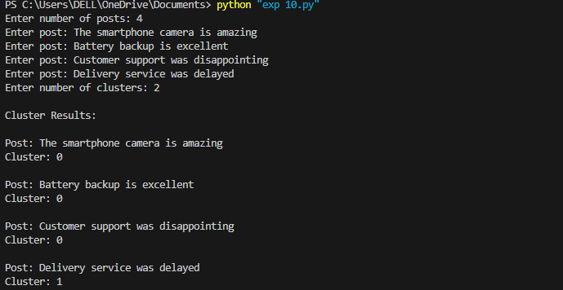

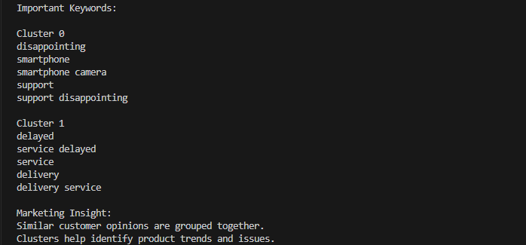

Result
Social media posts were successfully clustered using TF-IDF and K-Means. The clusters revealed customer interests, trends, and marketing opportunities.

